Quicken® for Mac Personal Finance Software 2005–2007
Account Conversion Instructions for Web Connect
 | As your financial institution completes its system conversion, you will need to modify your Quicken settings to ensure the smooth transition of your data. You will need to be able to log in to the Web site of your financial institution.  It is important that you perform the following instructions exactly as described and in the order presented. If you do not, your online service may stop functioning properly. This conversion should take 10 minutes.  Note: In the following screen shots, red icon numbers match step number instructions. All financial institution and register information is fictitious and for illustration only.  In this document, Quicken 2006 screen shots display. While the screens may look slightly different depending upon version, the functionality remains the same. Any instructional differences are clearly noted.

A. |  | BACK UP YOUR CURRENT DATA
- Quicken for Mac 2006 & 2007 customers: Choose File menu → Back Up → To Disk….
Quicken for Mac 2005 customers: Choose File menu → Save a Copy….
- Complete the following prompts.

B. |  | DOWNLOAD THE LATEST QUICKEN UPDATE
- Quicken for Mac 2006 & 2007 customers: Choose Quicken 2006 or 2007 menu → Check for Updates.
Quicken for Mac 2005 customers: Choose Quicken 2005 menu → Check for Updates.
- If a software update is available, then you will be prompted to download the update from the Quicken Web site.
- Once the update is complete, restart Quicken.

C. |  | GET YOUR LATEST TRANSACTIONS
 |  | - Choose Online menu → Download Transactions….  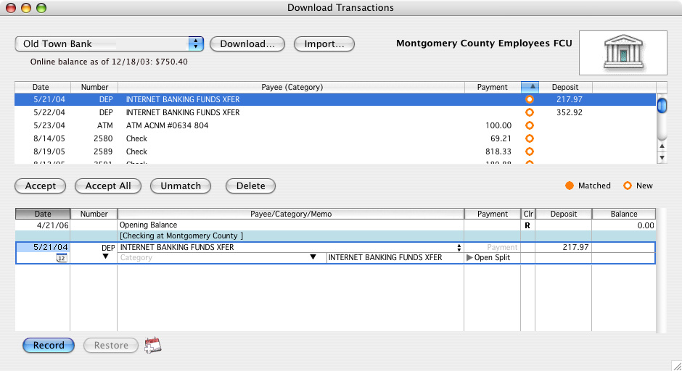  For 2005 customers:  Your Download Transactions dialog looks different from the 2006 version shown here.  Individually select both the Financial Institution: and Account: options. The Download… button is positioned to the right.  - Quicken for Mac 2006 & 2007 customers: Click to select your account from the drop-down list.  Quicken for Mac 2005 customers: Click to select your financial institution and account from the drop-down lists. (The note in the graphic explains how your Download Transactions dialog will look a little different.)  - Click Download….  - Enter your customer ID and PIN to log in to you financial institution’s Web site. Download your transactions into Quicken.  Note: You will not be able to download these transactions after the conversion.  Repeat steps 2 through 4 for each account (such as checking, savings, credit cards, and brokerage) that you will use for online banking and investing.  - Once the transactions are downloaded, accept all the transactions into your Quicken account register.  Important: You will not be able to proceed to the next section until you accept all transactions in the Download Transactions tab.  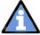 For help reconciling your account register, choose Help menu → Quicken Help. In the Ask a Question prompt, enter Reconciling an account.

D. |  | DISABLE YOUR ACCOUNTS FROM WEB CONNECT
- Choose Lists menu → Accounts.

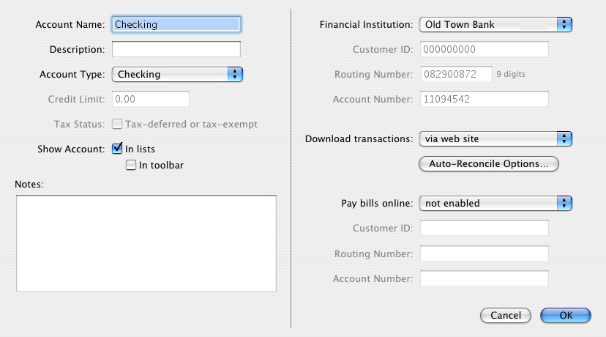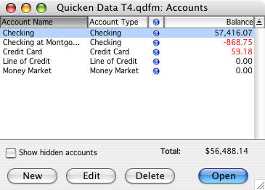
- Select the account you want to disable, and click Edit. Update Account Number and Routing Number as needed.
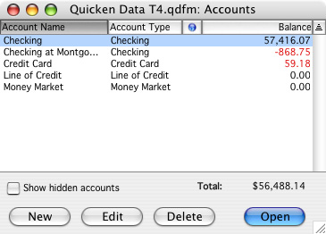
- In the Download transactions: drop-down list, select not enabled. Click OK to the prompt, “You are about to disable…” (not shown)
- Click OK to save your edits.
Repeat steps 2 through 4 for each online
account (such as checking, savings, credit cards, and brokerage). As
each online account is disabled, its blue online circle icon disappears.
Verify that your account list does not display blue online circle icons
for any accounts.

E. |  | ENABLE YOUR ACCOUNTS FOR WEB CONNECT
IMPORTANT: Complete section E after the conversion date.
- Log in to your Financial Institution’s Web site and download your transactions into Quicken.
Important: To avoid the possibility of creating duplicate records when downloading into Quicken, select a “from” date that does not include records previously downloaded from your financial institution.
- Click the Use an existing Quicken account radio button. In the corresponding drop-down list, select the Quicken account.

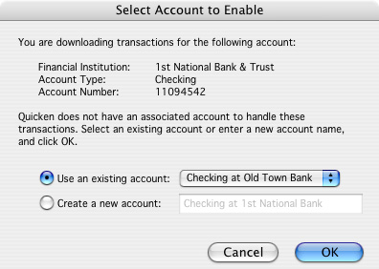
Select your existing account here.

Repeat steps 1 and 2 for each account that you will use for online banking or investing with your financial institution.

THANK YOU FOR MAKING THESE IMPORTANT CHANGES!

